Title: | Software Requirement Specification <Front-end Interface Subsystem>
Distribution | Development, Project Leader
Author | Spring Kunli.Zhou | Date: 2013-10-28
Review | See review section | Date: See review section
Approved
Remarks

Contents

1 Introduction 3
1.1 Scope 3
1.2 Definitions, Acronyms, and abbreviations 3
1.3 Document conventions 4
2 Overall description 4
3 Assumptions and dependencies 5
3.1 Assumptions 5
3.2 Dependencies 5
4 Constrain 5
4.1 ABB Framework 6
5 Non-functional requirement 6
5.1 Optimization Requirement 6
5.2 Module Test Requirement 6
5.3 Code Static check Requirement 6
5.4 Integration Test Requirement 6
6 Functional requirements 6
6.1 FEI communication hardware layer 7
6.2 FEI communication software design architecture 7
6.3 FEI data transmission specification 7
6.4 FEI data frame error check 7
6.5 FEI send/receive command data 7
6.6 FEI accept cmd request from subsystems 8
6.7 FEI check and interpreter data 8
6.8 FEI update diagnosis 8
7 Safety Requirements 8
8 Manufacturing 9
9 Requirements Review 9
9.1 Review Participants 9
9.2 Decision of the Review 9
9.3 Check List 9
9.4 Remarks 10
9.5 Defects 10
9.6 Changes are proved: 10
References 10
Revision History 10

List of Figures
Figure 1: CB software architecture 3
Figure 2: Front-end Interface Subsystem Use Case Diagram 5

List of Tables

Introduction

Scope
This document is intended to specify the software requirements for the Front-end Interface subsystem. Front-end interface subsystem in VT5 realizes the data transmission between Frontend board and Communication board.
The CB software architecture is showed as Figure 1.

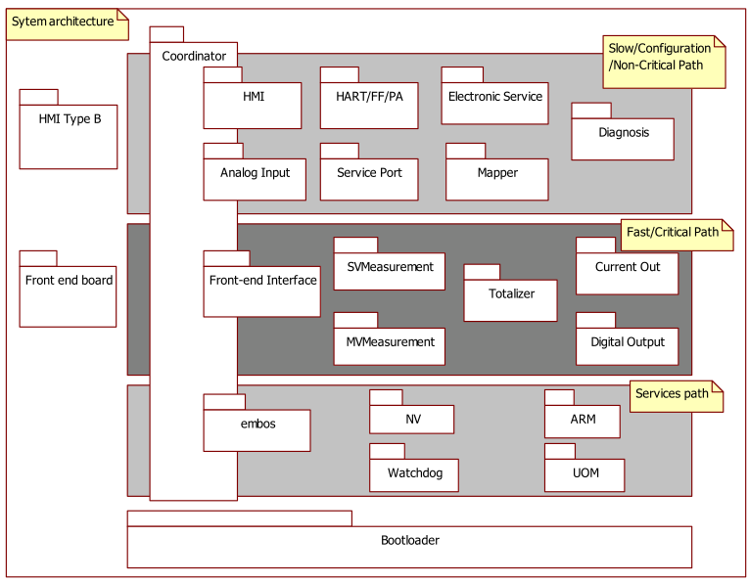
Figure 1: CB software architecture

Definitions, Acronyms, and abbreviations
Term | Definition
CB | Communication board
FE/FEB | Front-end Board
FEI | Front-end Interface
Diagnosis subsystem | 2Wire subsystem, responsible for handling error conditions and warnings. Also provides fastoutput behavior for fastoutput alarm subsystems.
Coordiantor Subsystem | 2Wire subsystem, is the system central subsystem which interacts with all other subsystems in the devices and finish many common functionality of the system.
CRC check | Cyclical Redundancy Checking
Frame number check | Every master request frame will generate an unique frame number, the slave response frame will return back this frame number. The master will check the consistency of the request and reply frame number.
Front-end busy | Front-end may be in busy state and refuse to accept CB command request.

Document conventions
Software requirements are identified using the following in-line table format:
Ident. | Definition / Motivation | Priority | Source
 |  | Stability | Source
Each field is described in the following list:

Ident. a unique identifier for the Requirement
Priority one of: Mandatory / Desirable / Future
Stability one of: Committed (Agreed by approvers) / Not yet agreed / Likely to change

Overall description

The Front-end Interface subsystem realizes the data transmission between FEB and CB through half-duplex UART hardware physical layer.
The subsystems put the command request to the Front-end Interface subsystem, and the FEI subsystem will process the data transmission. The Front-end subsystem makes the communication safe and efficient.
The following diagram is the use case diagram of Front-end Interface subsystem.
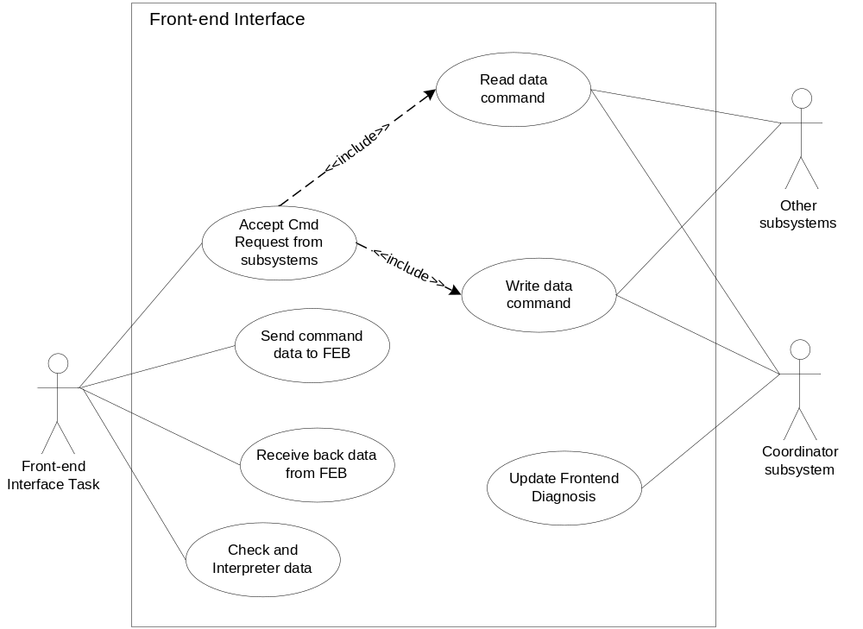
Figure 2: Front-end Interface Subsystem Use Case Diagram

Assumptions and dependencies

Assumptions
The transmission data validity is confirmed by subsystems, the FEI subsystem only check the validity of the data frame.
The FEI transmission mode is half-duplex mode, though the hardware layer can support full-duplex mode.

Dependencies

- Development and testing will be done regarding to the following conditions:
  - Compiler: IAR Compiler V3. 40
  - Framework: 2.3.1
  - Oscillator frequency: 3.6864 MHz

Constrain

ABB Framework

Ident. | Definition / Motivation | Priority  M | Source  R&D
FEI 4.1 | ABB Framework  Front-end Interface subsystem shall base on ABB framework.[1] | Stability  C | Source  R&D

Non-functional requirement

Optimization Requirement

Ident. | Definition / Motivation | Priority  M | Source  R&D
FEI 5.1 | Optimization  No compiler optimizations are permitted | Stability  C | Source  R&D

Module Test Requirement

Ident. | Definition / Motivation | Priority  M | Source  R&D
FEI 5.2 | Module test  FEI subsystem shall have module test | Stability  C | Source  R&D

Code Static check Requirement

Ident. | Definition / Motivation | Priority  M | Source  R&D
FEI 5.3 | Code Static check  FEI subsystem shall pass pc-lint check. | Stability  C | Source  R&D

Integration Test Requirement

Ident. | Definition / Motivation | Priority  M | Source  R&D
FEI 5.4 | Integration test  VT5 integration test shall include FEI subsystem. | Stability  C | Source  R&D

Functional requirements

FEI communication hardware layer
Ident. | Definition / Motivation | Priority  M | Source  R&D
FEI 6.1 | FEI communication hardware layer  1. Half-duplex UART physical layer.  2. Baud rate shall be 19200bps  3. 1 Start bit, 8 data bit, 2 stop bit, 1parity bit (odd parity).  4. LSB first | Stability  C | Source  R&D

FEI communication software design architecture
Ident. | Definition / Motivation | Priority  M | Source  R&D
FEI 6.2 | FEI communication software design architecture  Master –Slave architecture, CB as the master, FEB as the slave | Stability  C | Source  R&D

FEI data transmission specification
Ident. | Definition / Motivation | Priority  M | Source  R&D
FEI 6.3.1 | The maximum frame data length shall not exceed 255 bytes. | Stability  C | Source  R&D
Ident. | Definition / Motivation | Priority  M | Source  SRS  SIR-FE1
FEI 6.3.2 | The timeout for waiting for FEB reply shall not be less than 80ms.  The timeout for inter-character shall not be less than 3.5 characters transmission time and not be more than 4ms. | Stability  C | Source  SRS  SIR-FE1

FEI data frame error check
Ident. | Definition / Motivation | Priority  M | Source  SRS  SIR-FE1
FEI 6.4.1 | FEI data frame error check  The data frame shall use CRC check and frame number check. | Stability  C | Source  SRS  SIR-FE1

Ident. | Definition / Motivation | Priority  M | Source  SRS  SIR-FE1
FEI 6.4.2 | The reply data frame shall include error information when communication failures, including CRC error and some other specific information. Details see protocol specification | Stability  C | Source  SRS  SIR-FE1

FEI send/receive command data
Ident. | Definition / Motivation | Priority  M | Source  R&D
FEI 6.5.1 | The FEI shall send the command data to FEB and receive FEB response data. | Stability  C | Source  R&D

Ident. | Definition / Motivation | Priority  M | Source  R&D
FEI 6.5.2 | FEI command support  - FEI shall support common read data command  - FEI shall support common write data command | Stability  C | Source  R&D

FEI accept cmd request from subsystems
Ident. | Definition / Motivation | Priority  M | Source  R&D
FEI 6.6 | FEI can accept several command requests at the same time from different subsystem. | Stability  C | Source  R&D

FEI check and interpreter data
Ident. | Definition / Motivation | Priority  M | Source  R&D
FEI 6.7 | FEI shall check the frame validation and call subsystem process function to interpreter data. | Stability  C | Source  R&D

FEI update diagnosis

Ident. | Definition / Motivation | Priority  M | Source  TRS  4.1.7.18  SRS  SIR-FE1
FEI 6.8 | Provide an interface to update the FEB diagnosis information to Diagnosis subsystem. | Stability  C | Source  TRS  4.1.7.18  SRS  SIR-FE1

Safety Requirements

Ident. | Definition / Motivation | Priority  M | Source  SRS  SIR-FE1
FEI 7.1 | Information redundancy  The transmission data shall include a calculated checksum (such as CRC checksum), which shall be re-calculated by receiver, in order to ensure data correction.  The transmission data shall include a frame number, the response data shall with the same frame number. | Stability  C | Source  SRS  SIR-FE1

Ident. | Definition / Motivation | Priority  M | Source  R&D
FEI 7.2 | Transmission redundancy  The transmission data shall be transferred several times in sequence when transmission fails. The maximum retry time is 3. | Stability  C | Source  R&D

Ident. | Definition / Motivation | Priority  M | Source  SRS  SIR-FE3
FEI 7.3 | Validity of Dynamic data  FEI shall check the validity of Dynamic data.  - Duplicated data check for frequently- updated data.  - CRC check for non-frequently updated data. | Stability  C | Source  SRS  SIR-FE3

Ident. | Definition / Motivation | Priority  M | Source  SRS
FEI 7.4 | The FEI subsystem is in the safety loop. Refer to VT5 safety concept [5]. | Stability  C | Source  SRS

Manufacturing

None

Requirements Review

Review Participants
Place | Dept. | Name
Shanghai | R&D | Paul Li | 2012-06-11 rev 0.2
Shanghai | R&D | Vincent liu, Lawrence | 2013-04-28 rev 0.3
Shanghai | R&D | Merrick Huang | 2014-01-08 rev 0.4

Decision of the Review

 | Decision | Next steps
○ | Inspection passed without restrictions | Phase finished
 | Inspection passed with restrictions | some changes must be done
❑ | Inspection not passed | Inspection must be repeated

Check List

 |  | Yes | No | N.A.
1. | Does the specification explain the currently known requirements that the product finally has to perform? | Y
2. | Are complex subjects explained? | Y
3. | Are all used abbreviations and technical expressions explained? | Y
4. | Are all referenced documents in the reference list? | Y
5. | Contains the document a rough overview of the product’s main functionality? | Y
6. | Are all requirements referenced? | Y
7. | Are all requirements testable? | Y
8. | Is the typical environment of the product described? | Y
9. | Is defined which components already exist, will be bought or self-written? | Y
10. | Are safety requirements (e.g error-detection, error-handling) specified? | Y
11. | Are service/update requirements described? | Y
12. | Are all dependencies to other requirement documents considered? | Y
13. | Are templates used in a correct manner? | Y
14. | Are all open issues transferred to the defects table? | Y

Remarks

Defects
No. | Checkpoint | Description | Major Defect | done  Date
1 | 3.1 | Add assumptions of the transmission | N | 2012.6.11
2 | FEI7.1 | Add frame number check description | N | 2012.6.11
3 | FEI7.4 | Add safety loop description | N | 2012.6.11
4 |  | Change some description of the content | N | 2012.6.11
5 |  | The document shall add trace of TRS | N | 2013.4.28
6 | FEI 6.2 | Delete OSI model definition | N | 2013.4.28
7 |  | Delete origin FEI6.4 process priority requirement, it is not the FEI function to define | N | 2013.4.28

Changes are proved:
The Reviewer confirms that all changes are done:
Proved Rev: | Date: | Reviewer:
0.3 | 2013-05-16 | Lawrence Shi  Vincent Liu
0.4 | 2014-01-08 | Merrick Huang

References
Ref. | Document
[1]
  ABB BUI Common Framework release 2.3.1
[2] | [RS004]VT5 Software Requirement Specification
[3] | Modbus_Application_Protocol_V1_1b.pdf
[4] | Modbus Over Serial Line V1.02.pdf

Revision History
Rev. | Description of Version/Changes | Primary Author(s) | Date
0.1 | Initial revision. | Spring Zhou | May-16 2012
0.2 | Modify after internal review by Paul Li. | Spring Zhou | June-11 2012
0.3 | Modify after review by Lawrence and Vincent. | Spring Zhou | April-28 2013
0.4 | Correct some typos. | Zuochen Wang | Oct-28 2013

